Radius of sun 696,000 km
Radius of Moon = 1,740 km
Temperature of sun’s surface 5780 K
Solar Flux at Earth’s orbit = 1366 W/m²
= 5.67 * 10⁻⁸ W/m²*K⁴
Area of circle = 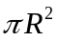
Surface area of sphere =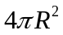
Distance Sun to Mercury = 58 * 10⁶ Km Distance Sun to Venus 108 * 10⁶ km
Distance Sun to Earth = 149 * 10⁶ km
Distance Earth to Moon = 3.8 * 10⁵ km
Albedo Earth = .30
Albedo Earth’s Atmosphere = .25
Albedo Earth’s Surface = .05
Albedo Mercury =.12
Albedo Venus = .80
Albedo Moon = .12
Celsius + 273.15 = Kelvin
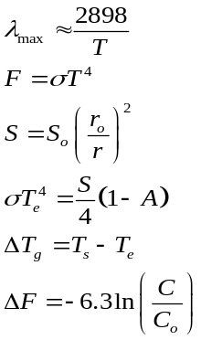

Radius of sun 696,000 km
Radius of Moon = 1,740 km
Temperature of sun’s surface 5780 K
Solar Flux at Earth’s orbit = 1366 W/m²
= 5.67 * 10⁻⁸ W/m²*K⁴
Area of circle =
Surface area of sphere =
Distance Sun to Mercury = 58 * 10⁶ Km
Distance Sun to Venus 108 * 10⁶ km
Distance Sun to Earth = 149 * 10⁶ km
Distance Earth to Moon = 3.8 * 10⁵ km
Albedo Earth = .30
Albedo Earth’s Atmosphere = .25
Albedo Earth’s Surface = .05
Albedo Mercury =.12
Albedo Venus = .80
Albedo Moon = .12
Celsius + 273.15 = Kelvin

